University of Canberra

Faculty of Science and Technology

**Web Design and Programming (7175 & 6691)**

**Assignment 1 - Hint**

**Submission date**: Sunday 23:59 20/09/2020 (Week 7)

**Type**:Individual assignment

**Total mark**:20

**Proportion of unit assessment**:20%

**Submission**:A .zip file that contains

* 7 HTML files (**Index.html**, **Restaurants.html**, **Cuisines.html**, **Dishes.html**, **Prices.html, Locations.html**,and **ContactAbout.html**)
* 1 CSS file (**site.css**), 1 JavaScript file (**site.js**) and 1 jQuery file (**jquery.js**)
* 1 folder (**bootstrap**) that contains Bootstrap files (optional)
* 1 MS Word file about how you design the Dishes, Prices, and Contact & About pages

**Late submission**: 5% of the total mark (i.e., 1 mark) per day. Information on how to apply for extension can be found in the unit outline available on the Canvas site of this unit.

**Topic**: **Canberra Restaurants**

**Tasks**: Design and implement a responsive website for the above topic using the following:

* **HTML5, CSS3, Bootstrap, Flex** and **Media Query** for **responsive web design**.
* **JavaScript** and **jQuery** for **interactive website**.

**Requirements**:

1. **Website**: full-width layout, responsive design, and having 7 pages including **Home** page, **Restaurants** page, **Cuisines** page, **Dishes** page, **Prices** page, **Locations** page, and **Contact & About** page for contact and about this website. Links to those pages are available as menu items on the main menu of the website.

* Example of full-width layout website: <https://www.ibm.com/services/artificial-intelligence>
* Example of boxed-design (not full-width ) layout website (not used for this assignment): <https://www.headland.com.au/industry-4-0-cheat-sheet-industry4-0-cloud-computing-smart-factory-internet-of-things/>
* Example of responsive website: <https://www.microsoft.com/en-us/ai/default.aspx>
* Example of non-responsive website (not used for this assignment): <http://www.fordperformanceact.com/>

1. **Home page (Index.html):** to introduce Canberra Restaurants website and 6 restaurants: Belluci’s Italian, Italian and Sons, Chairman & Yip, Dickson Asian Noodle House, Blu Ginger, and Jewel of India. Please see screenshots below for design.
2. **Restaurants page (Restaurants.html):** to list the 6 restaurants found on the restaurants page. Brief information on cuisine, dishes, price and location is found on this restaurants page. Please see screenshots below for design.
3. **Cuisines page (Cuisines.html):** to list the 6 restaurants found on the home page in 3 different cuisines (Italian, Asian and Indian). Details are shown below.
4. **Dishes page (Dishes.html):** to list the restaurants found on the home page in different dishes (at least 3, for example fish & chips, pasta, and dumplings). Details are shown below.
5. **Prices page (Prices.html):** to list the restaurants found on the home page in different prices (at least 3, for example cheap eats, mid-range and fine dining). Details are shown below.
6. **Locations page (Locations.html):** to display a Google map with markers for all restaurants. Each marker provides name, image and excerpt for the selected restaurant and a hyperlink to the own web page of this restaurant. Details are shown below.
7. **Contact & About page for contact, about and other information (ContactAbout.html):** to present contact details, information about this website, copyright, and other useful information on Canberra restaurants. Details are shown below.
8. Please ***do not*** use ASP.NET Core or any Web Builder tool to implement this website. All web pages are in **.html** files. You can use Visual Studio as an editor to write HTML, CSS, JavaScript, jQuery, etc. but you cannot use any existing template to build this website.
9. Handle all exceptions that may occur at runtime (– 1 mark for each exception found). Make sure your web site provides the same display in the following web browsers: Chrome and Edge (– 2 marks if not the same).

**Details**

**Home page:** to introduce Canberra Restaurants website and 6 restaurants: **Belluci's Italian**, **Italian and Sons**, **Chairman & Yip**, **Dickson Asian Noodle House**, **Blu Ginger**, and **Jewel of India**. **You need to implement this page with the same design (texts, images, space, layout, etc.) as seen in the screenshots below**.

*The home page below will be displayed on your web browser when you open it. The user can also click on* **Canberra Restaurants** *on the* ***main******menu*** *to open this home page:*

*Navigation bar: Week 4 Tutorial Example 8*

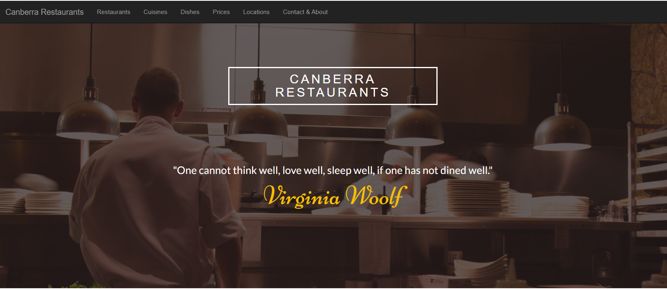

*Use details in background image to locate texts. Text font? See Week 3 Tutorial*

*To make the background image darker, set* background-color: rgba(31, 20, 20, 0.7); *How? See lecture recordings on Thu 3/9/2020*

*This screenshot was captured with browser width = 1380px*

*Note this website uses* ***full-width*** *layout*

*Note:* ***Parallax Scrolling*** *technique is applied to this dark background image, you can see it from the second screenshot below when you scroll down a bit.*

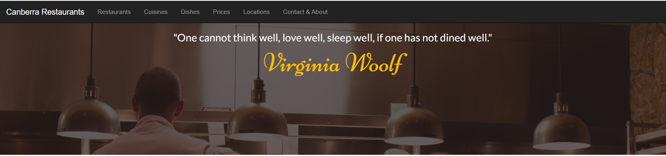

*Parallax scrolling? See Week 3 Tutorial*

*Keep scrolling down you will see the following*

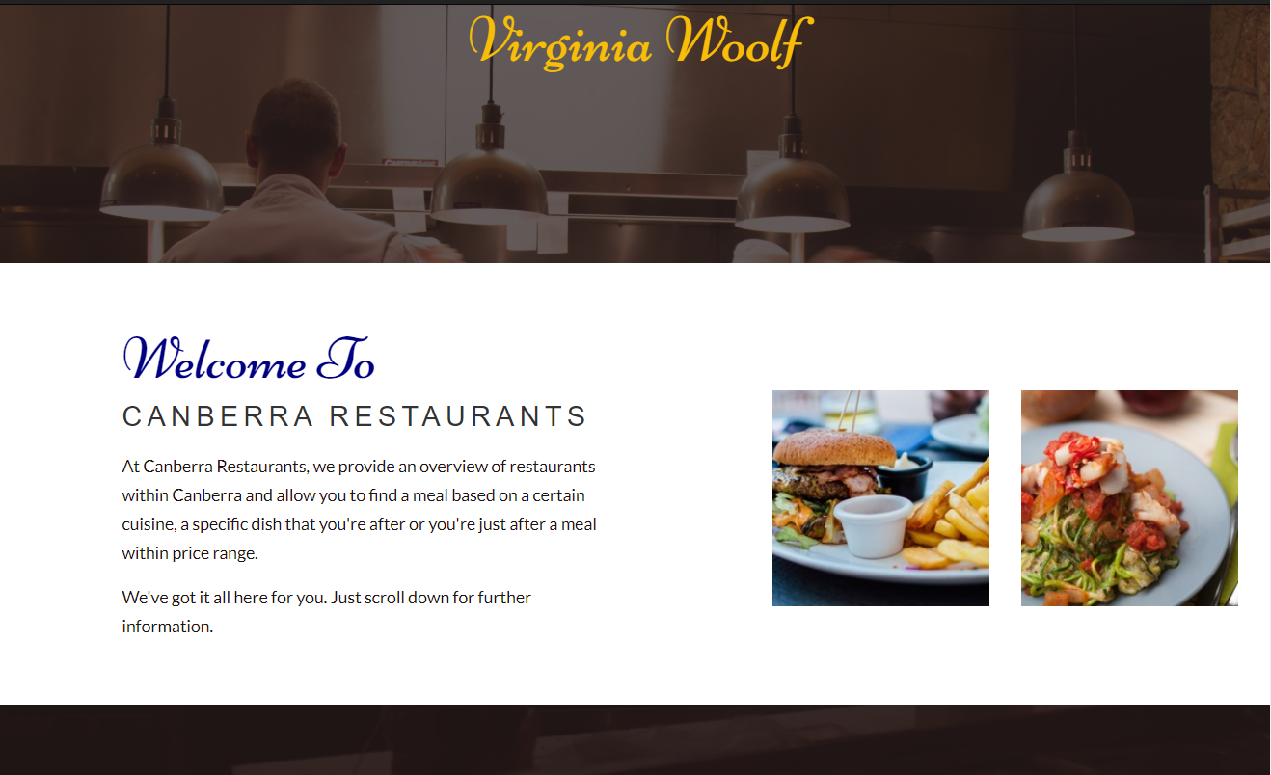

*Use* ***container-fluid*** *css class for full-width layout here*

*Same margins*

*1 bootstrap row with 12 columns*

*1 bootstrap row with 12 columns*

*6 columns*

*6 columns*

*1 column*

*1 column*

*5 columns*

*5 columns*

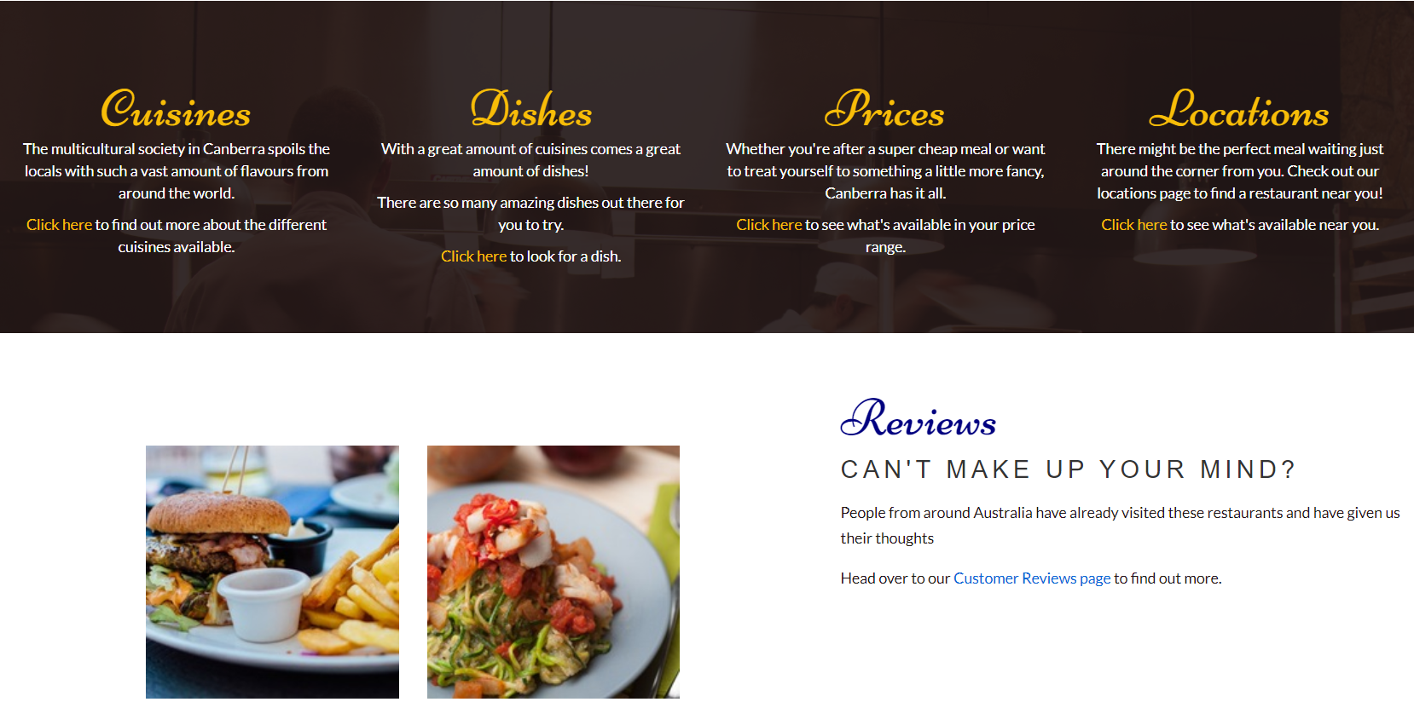

*3 columns*

*3 columns*

*3 columns*

*3 columns*

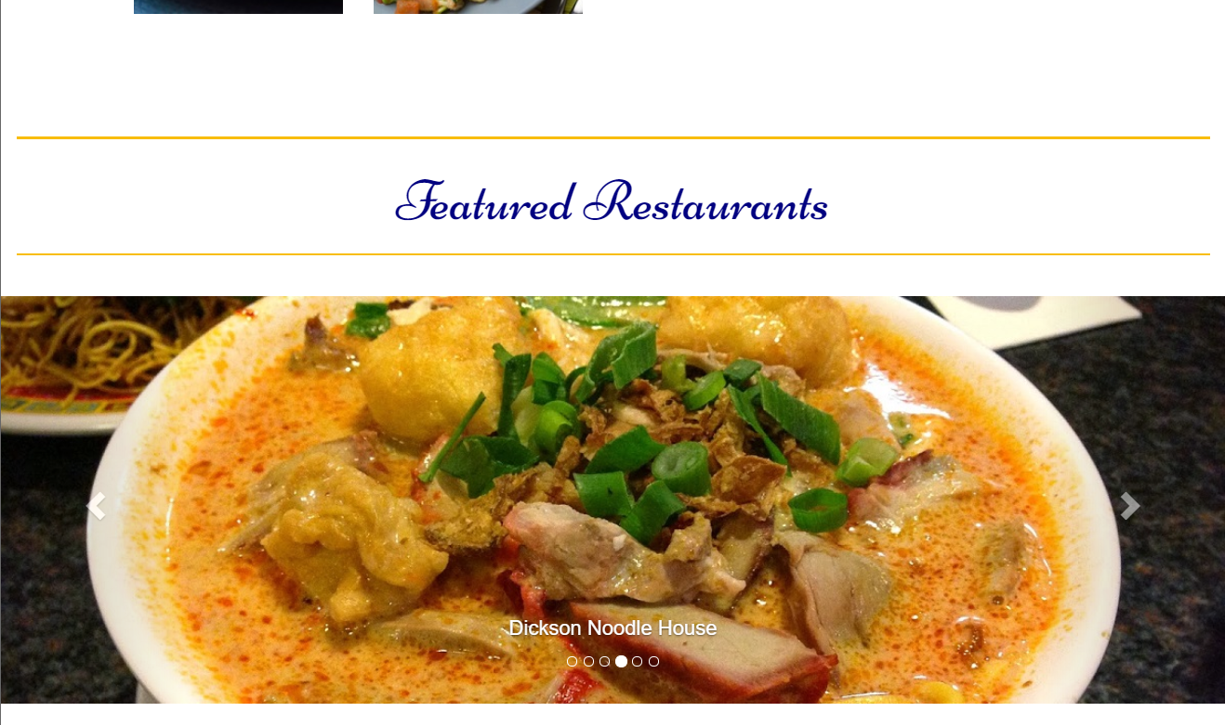

*<hr /> use this css*  border: none; height: 2px; background-color: #f8bd08;

}

(*See full picture for this missing part below*)



*This carousel uses old Bootstrap, you can use the latest one as seen in Week 4 Tutorial Question 2 (working version available in* ***Answer to Week 4 Tutorial Questions****)*



*Note:* ***Bootstrap Carousel*** *technique is applied to the last screenshot above, you can see all 6 images from the screenshots below. If the user clicks on one of these 6 images, the restaurant’s own website will be displayed on your web browser.*

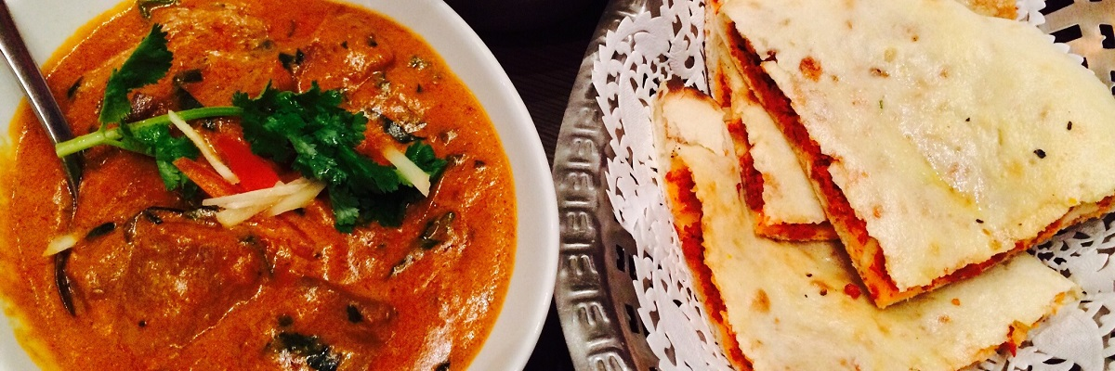

Blu Ginger

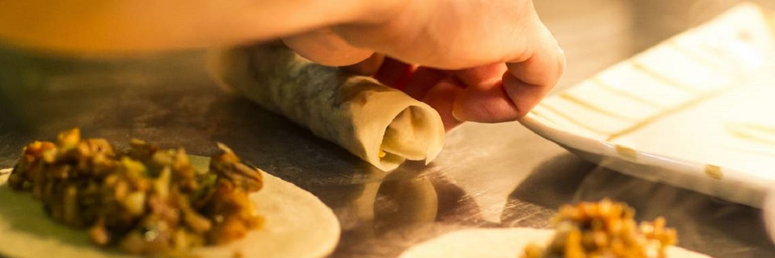

The Chairman and Yip

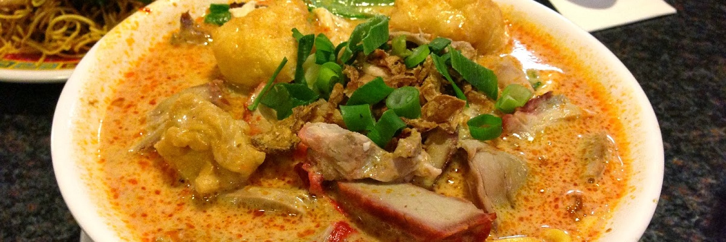

Dickson Noodle House

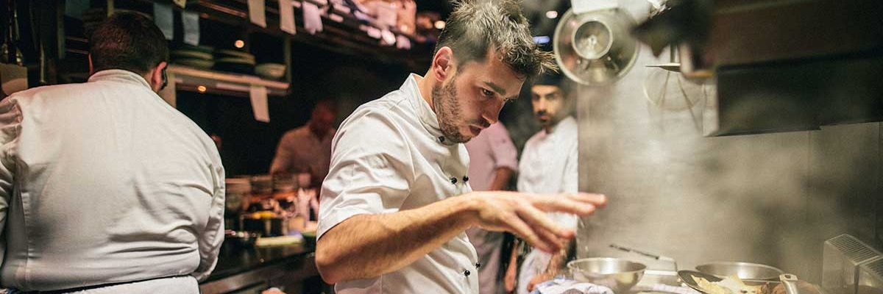

Italian and Sons

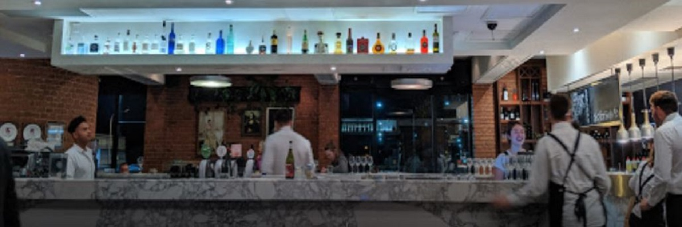

Belluci's Italian

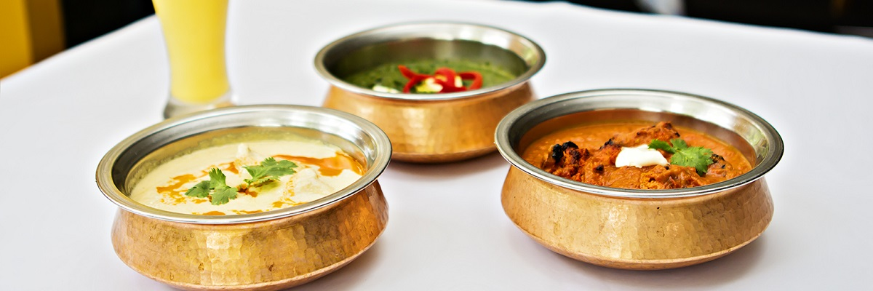

Jewel of India

**Responsive design**: If you resize the width of your web browser to a **tablet size or mobile phone size**, the design of this web page must be changed as seen below.

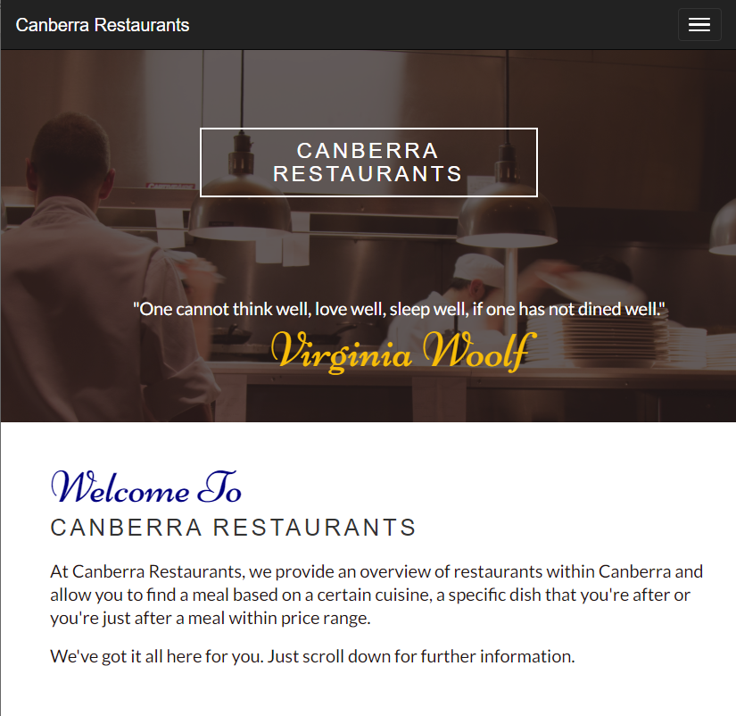

*6 columns*

*6 columns*

*12 columns*

*Use details in background image to locate texts.*

*This screenshot captured when the navigation bar has changed to this tablet mode*

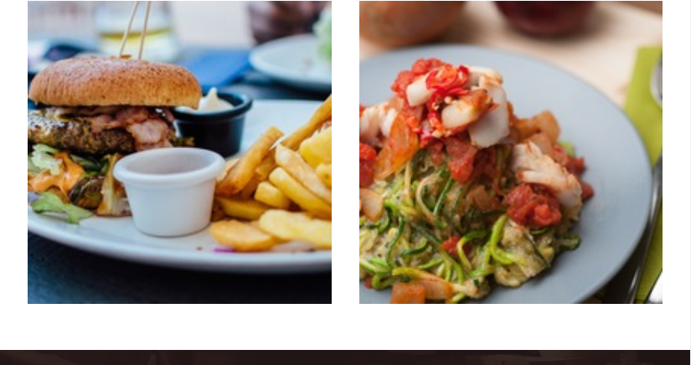

(*See full picture for this missing part below*)

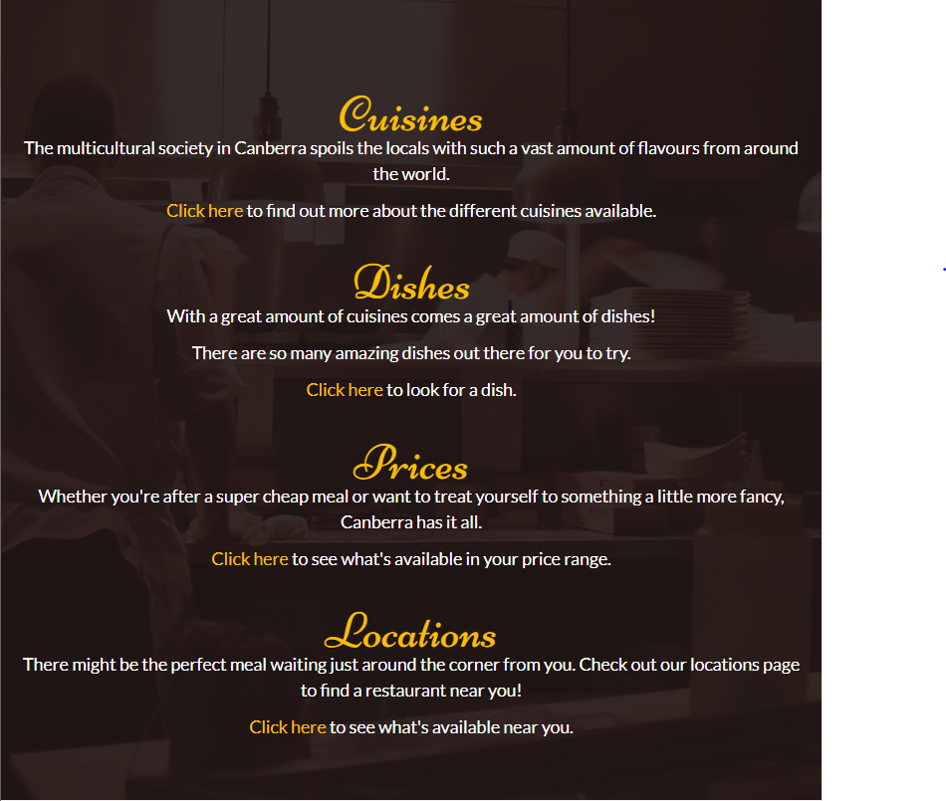

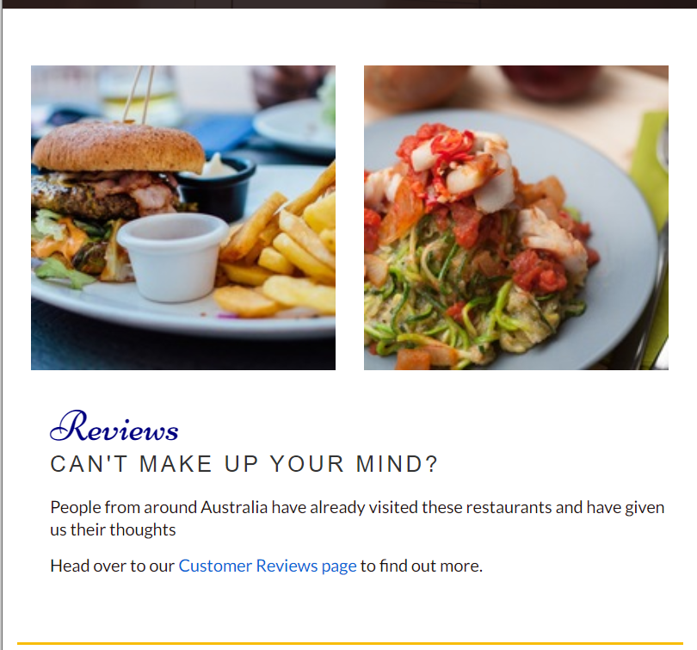

(*See full picture for this missing part below*)

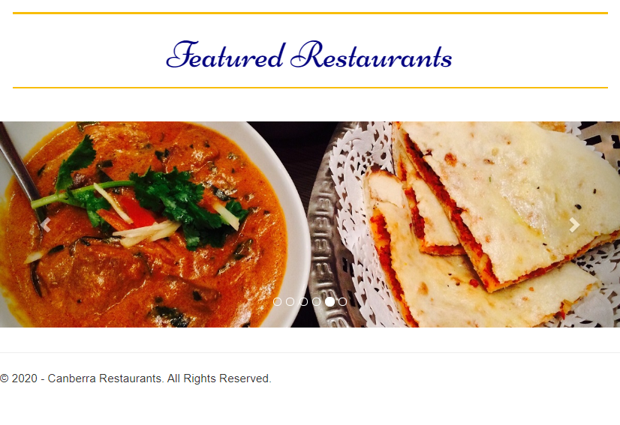

The sizes of images and texts on this web page are reduced accordingly as seen on the screenshots above (for both tablet and mobile phone).

**Restaurants page (Restaurants.html):** to list the 6 restaurants found on the restaurants page. Brief information on cuisines, dishes, prices and locations is found on this restaurants page.



The main menu and the first block have the same design as those on the Home page except the quote "One cannot think well, love well, sleep well, if one has not dined well." and author Virginia Woolfare replaced by **Restaurants** (see the screenshot below)

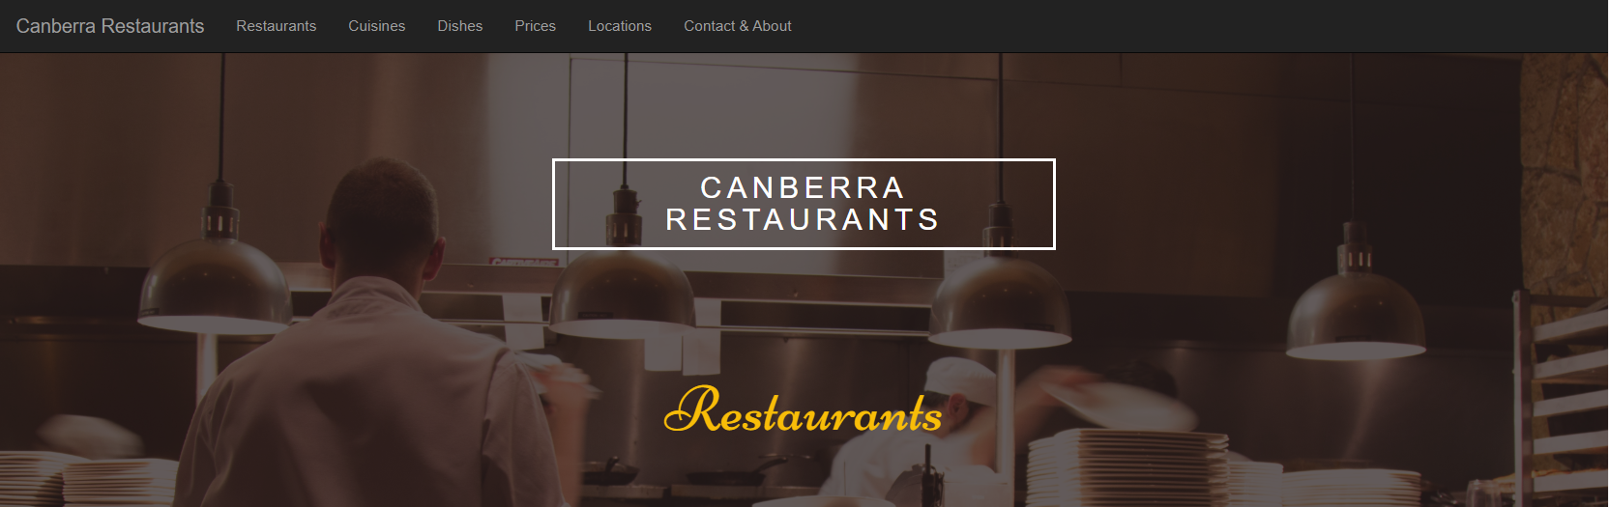

The next 6 blocks **R1, R2, R3, R4, R5, R6** are for the 6 restaurants and need to be designed as follows

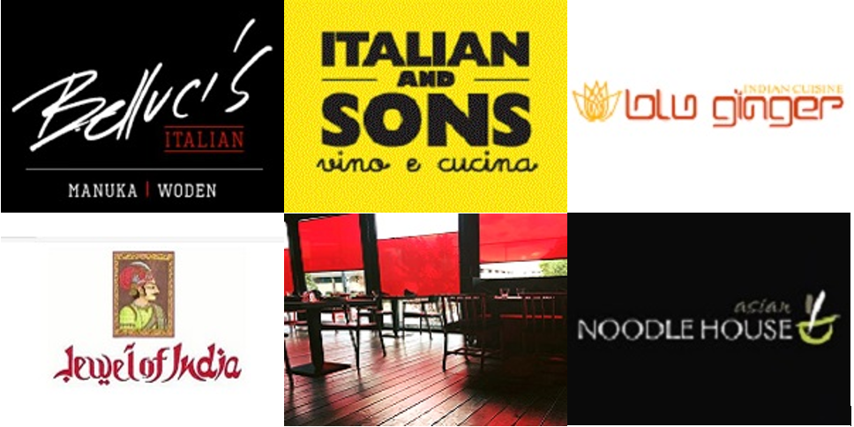

*No space between these 6 images. See Week 3, 4, 5, 6 tutorials about them*

When the user moves the mouse over on a block (e.g., Italian and Sons), the information for this block appears. If the user clicks on WEB SITE, the own website of this restaurant will appear on the web browser. For example,

 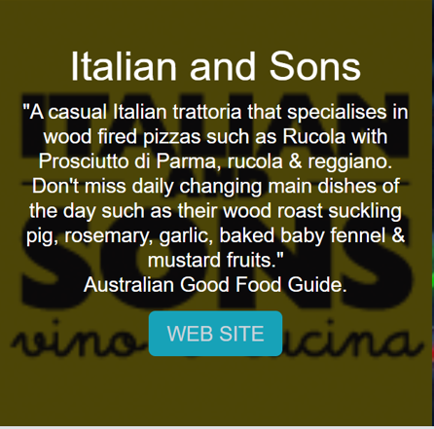

*See Week 3 tutorial*

Italian and Sons website opens

*WEBSITE Clicked*

*mouse over*

Text displays on each of the 6 blocks:

* **Belluci’s Italian**: "Belluci's demonstrates a new concept, a new food philosophy – the dawn of a new era in Canberra dining. Having been established more than 20 years ago, Belluci's fast became an iconic name in Canberra. To bring you the finest dishes, we’ve gone back to traditional Italian routes, creating simple, rustic food." Belluci's Italian Website.
* **Italian and Sons**: "A casual Italian trattoria that specialises in wood fired pizzas such as Rucola with Prosciutto di Parma, rucola & reggiano. Don't miss daily changing main dishes of the day such as their wood roast suckling pig, rosemary, garlic, baked baby fennel & mustard fruits." Australian Good Food Guide.
* **Blu Ginger**: "At Blu Ginger we use only the freshest locally sourced produce, combined with authentic spices imported directly from the sub-continent, to offer classic, traditional recipes with a modern twist, creating a unique and memorable dining experience for you." Blu Ginger Website.
* **Jewel of India**: "Finding a balance between dishes inspired by authentic recipes and creating a modern take on classic cuisine sees a loyal following of Canberra locals returning for a mouth-watering feast." Australian Good Food Guide Website.
* **Chairman & Yip**: The Chairman & Yip has become one of Canberra’s longest standing and most highly regarded institutions, having received numerous awards over the years, offering an ever consistent and professional quality of service for corporate dining, conferences and presentations.
* **Dickson Asian Noodle House**: "The Dickson Asian Noodle House specialises in traditional Malaysian, Thai and Lao cuisine. The dining atmosphere is casual and cosy providing for a la carte dining, banquets and take away." Vibe FM Website.

**Links** to websites for the 6 restaurants:

* **Belluci’s Italian**: <https://bellucis.com.au/home.php>
* **Italian and Sons**: <http://italianandsons.com.au/>
* **Blu Ginger**: <http://www.bluginger.com.au/>
* **Jewel of India**: <http://www.jewelofindia.com.au/>
* **Chairman & Yip**: <http://chairmangroup.com.au/chairmanyip/>
* **Dickson Asian Noodle House**: <https://www.facebook.com/pages/Dickson-Asian-Noodle-House/156690017692038>

The **Footer (Copyright)** is the same as that on the Home page:



The sizes of images and texts on this web page are reduced accordingly (for both tablet and phone).

**Cuisines page (Cuisines.html):** to list the 6 restaurants found on the home page in 3 different cuisines which are Italian, Asian and Indian.

The main menu and the first block have the same design as those on the **Restaurants** page except the title **Restaurants** is replaced by **Cuisines** as follows

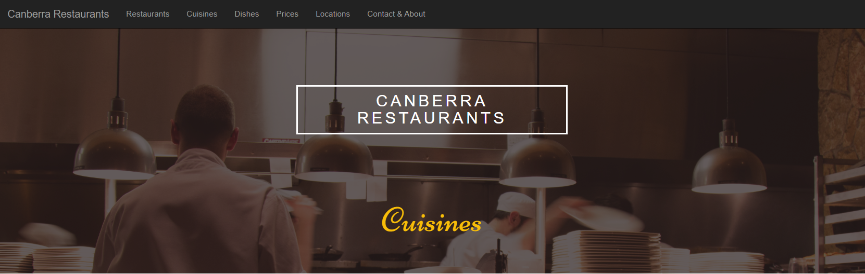

The remaining of the page is just the ***Bootstrap Accordion***below and Footer (Copyright).

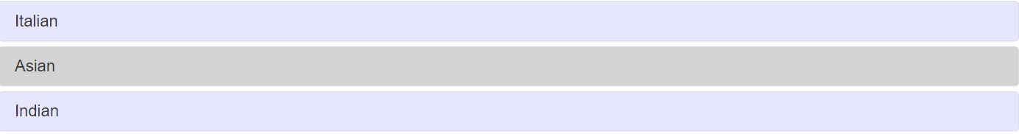

If the user clicks on Italian, it will expand to see restaurants for that cuisine.

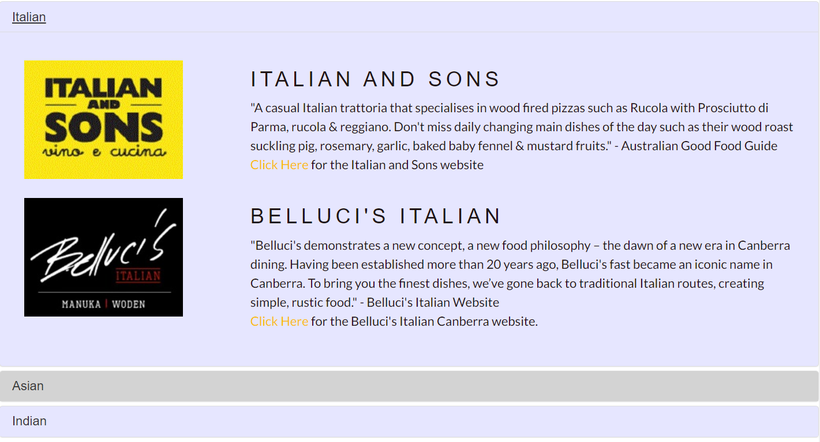

*See Week 4 Tutorial. Note 3 tabs closed at the beginning. When the user clicks on a tab, only that tab opens, and the other 2 tabs are closed*

If the user clicks on **Asian**, it will expand to see restaurants for that cuisine.

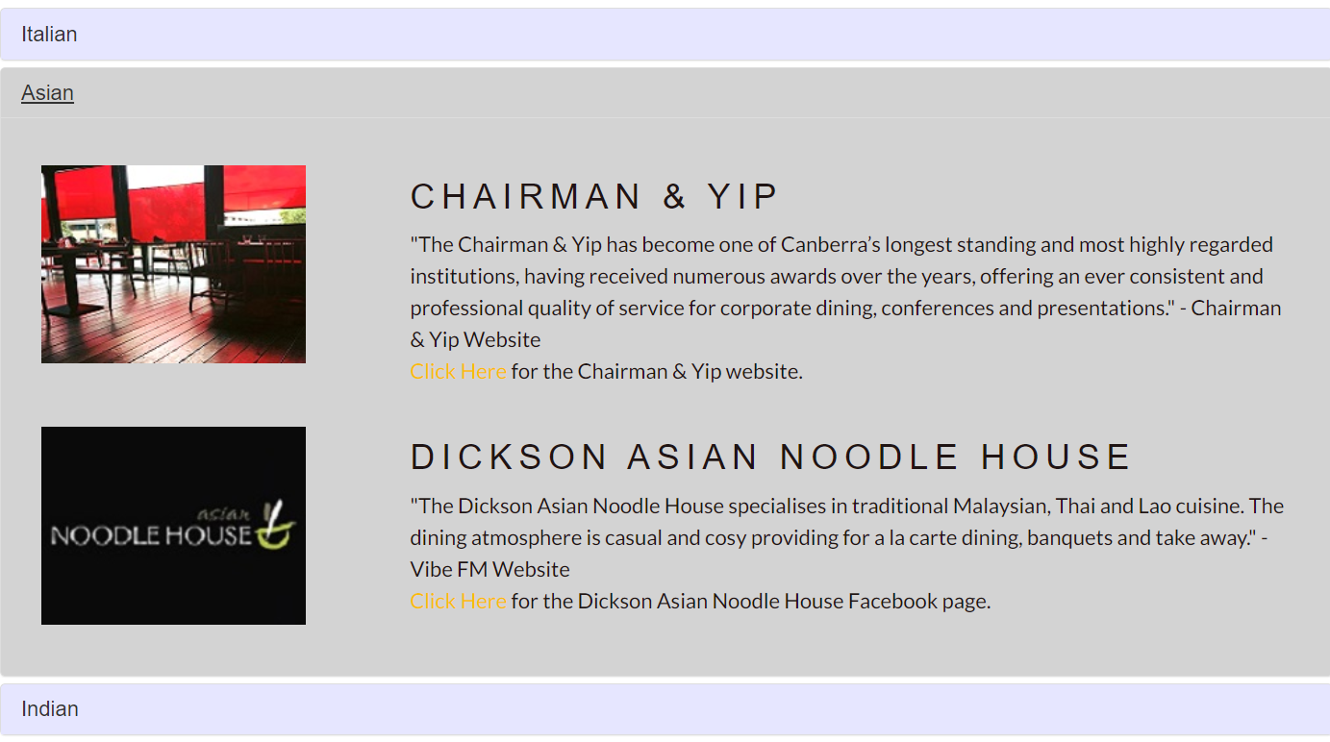

If the user clicks on Indian, it will expand to see restaurants for that cuisine.

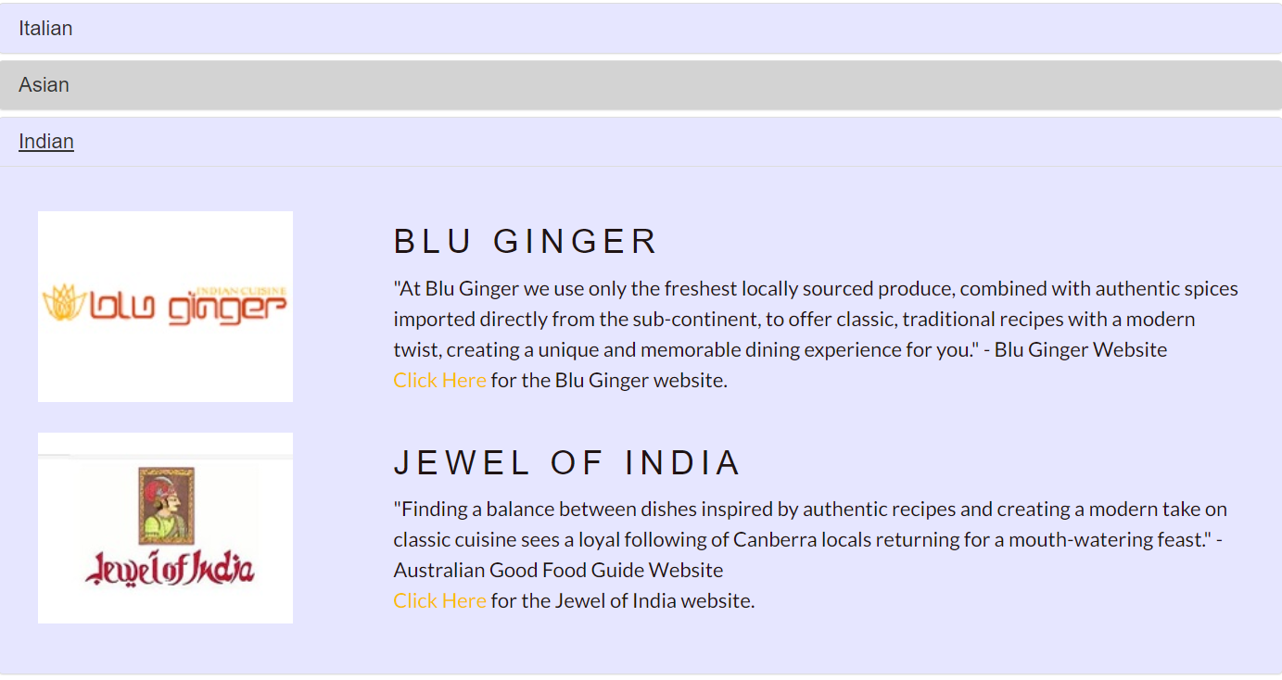

The **Footer (Copyright)** is the same as that on the Home page:



**Responsive design**: If you resize the width of your web browser to a **tablet size or mobile phone size**, the design of this web page must be unchanged except text font sizes and image sizes would be smaller.

**Dishes page (Dishes.html):** to list the restaurants found on the home page in different dishes (at least 3, for example fish & chips, pasta, and dumplings).

**You will design this web page yourself. The requirements are**

* **This web page is responsive and consistent with other pages on this website, and**
* **The design techniques you use are different from those on other pages (i.e., Parallax Scrolling, Bootstrap Carousel, and Bootstrap Accordion cannot be used here).**

**Prices page (Prices.html):** to list the restaurants found on the home page in different prices (at least 3, for example cheap eats, mid-range and fine dining). Details are shown below.

**You will design this web page yourself. The requirements are**

* **This web page is responsive and consistent with other pages on this website, and**
* **The design techniques you use are different from those on other pages (i.e., Parallax Scrolling, Bootstrap Carousel, Bootstrap Accordion, and the techniques on Dishes page cannot be used here).**

**Locations page (Locations.html):** to display a Google map with markers for all restaurants. Each marker provides name, image and excerpt for the selected restaurant and a hyperlink to the own web page of this restaurant.

The main menu and the first block have the same design as those on the **Restaurants** page except the title **Restaurants** is replaced by **Locations** as follows

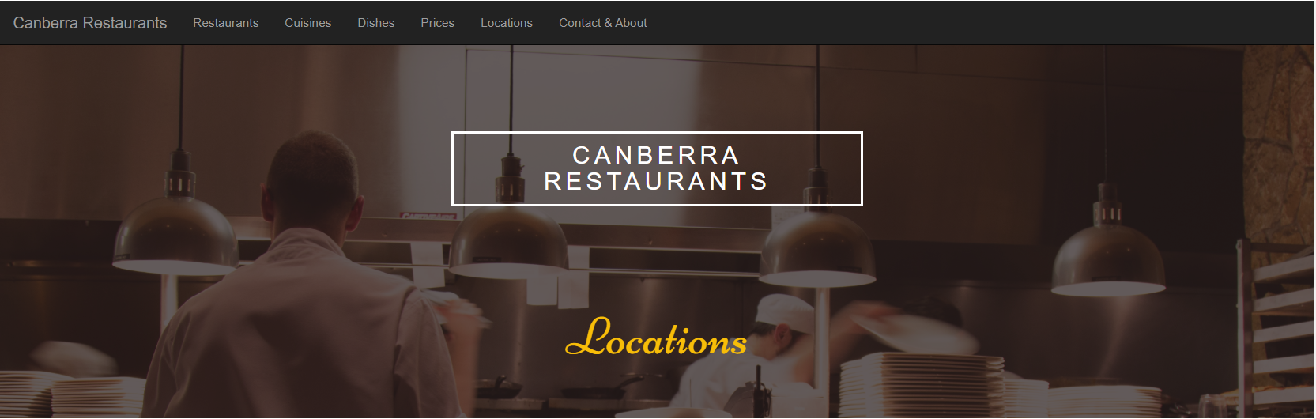

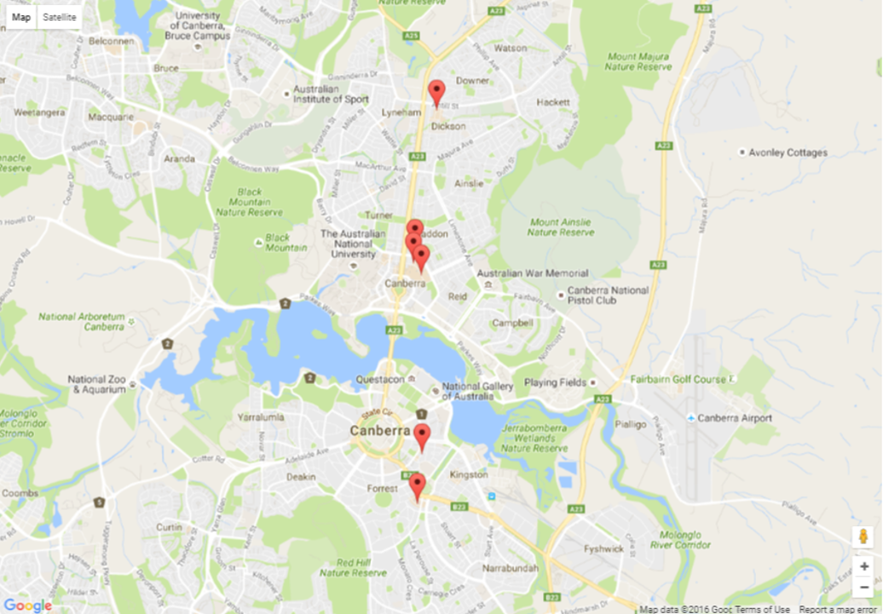

*See Week 5 Tutorial. The GPS locations can be found on Google. The locations can be different from this screenshot, but not significantly different.*

*If the user clicks on a marker, an info window for that restaurant will appear. If the user clicks on the link* ***Click Here*** *on the info window, the own website of that restaurant will appear.* For example,

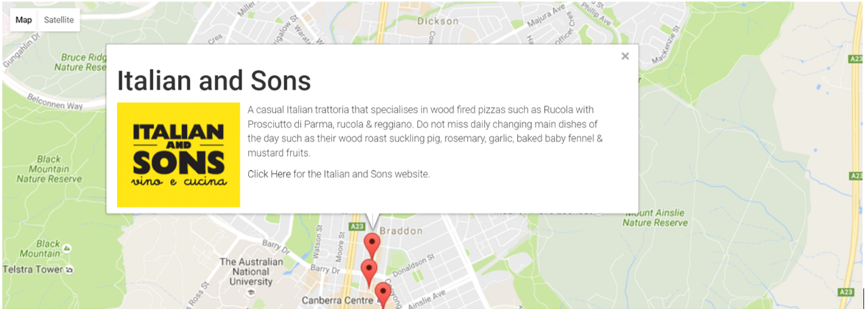

The **Footer (Copyright)** is the same as seen on other pages above.



**Responsive design**: If you resize the width of your web browser to a **tablet size or mobile phone size**, the design of this web page must be unchanged except text font sizes and image sizes would be smaller.

**Page for contact, about and other useful information (ContactAbout.html):** to present contact details, information about this website, copyright, and other useful information on Canberra Restaurants.

**You will design this web page yourself. The requirements are**

* **This web page is responsive and consistent with other pages on this website, and**
* **The design techniques you use are different from those on other pages (i.e., Parallax Scrolling, Bootstrap Carousel, Bootstrap Accordion, and the techniques on Dishes and Prices pages cannot be used here).**

**Marking Guideline (max 20 marks, more details will be available in Submission box in Canvas)**

* [5 marks] Home page
* [4 marks] Restaurants page
* [3 marks] Cuisines page
* [2 marks] Dishes page
* [2 marks] Prices page
* [2 marks] Locations page
* [1 mark] Contact & About page
* [1 mark] Main menu and Footer
* [– 2 marks] How to design Dishes, Prices, Contact & About pages not found in Report
* [– 2 marks] Incorrect filenames and folder name for submission
* [– 2 marks] For each exception found in HTML, CSS, JavaScript, and jQuery
* [– 2 marks] Web pages not the same design when appearing on Chrome and Edge

Lectures on Thursdays and Tutorials/Labs from Week 2 to Week 7 will help you design and implement this website.

Your assignment will be marked by your tutor. Please contact your tutor for further information on your mark.

Visit Virtual Room and Discussion forum on the Canvas site of this unit for more information posted by lecturer, tutors and other students.

Assignment extension: details in Unit Outline on Canvas.